SERVERLESS WEBAPPLICATION: AWS

GET

getemployeedeailsbyemail

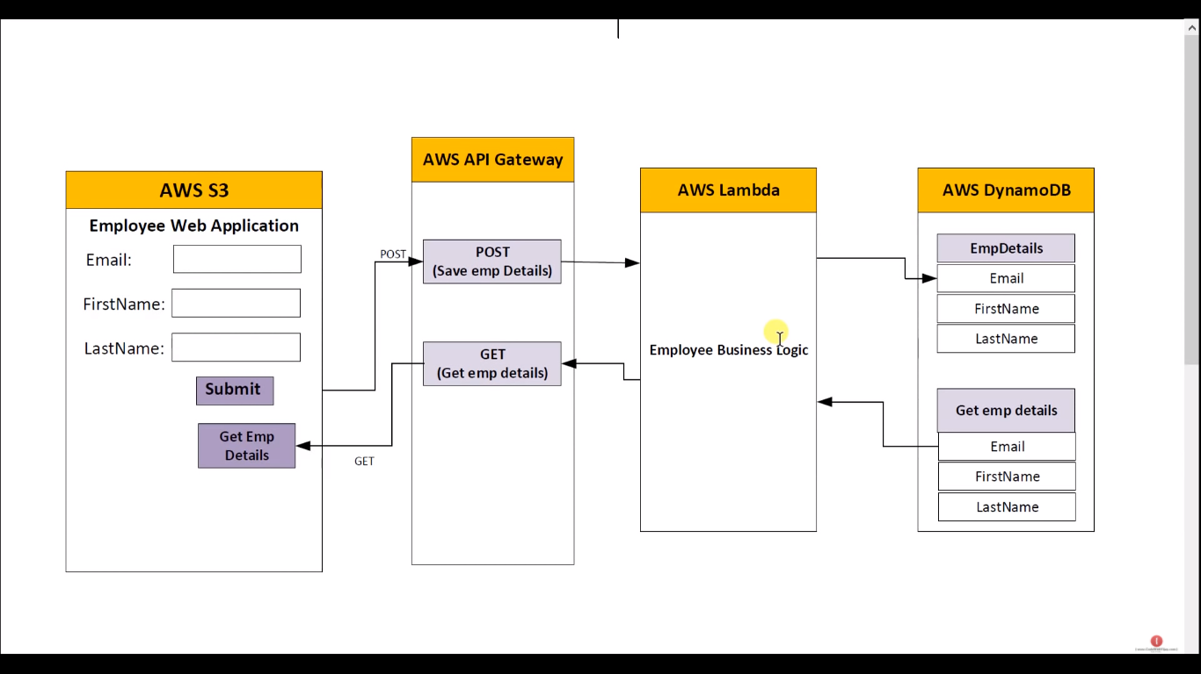

SERVICE

API GATEWAY

REST API

NEW: GetEmployeeDetailsByEmail

Action:

Resource

resourcename: getcustomerdetailsbyemail

create resource

action: method

Get

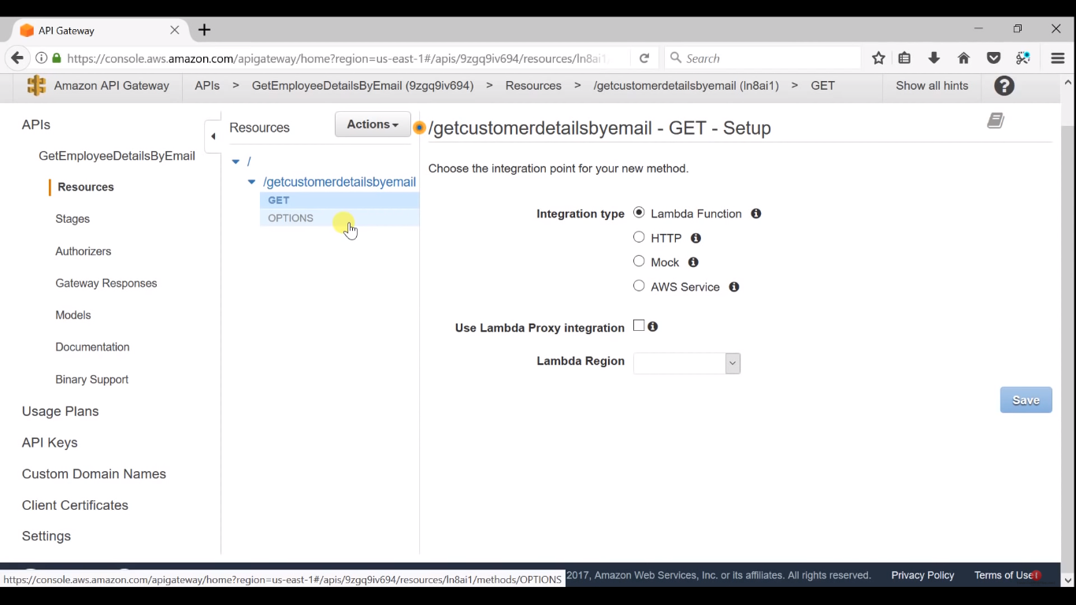

mock

save

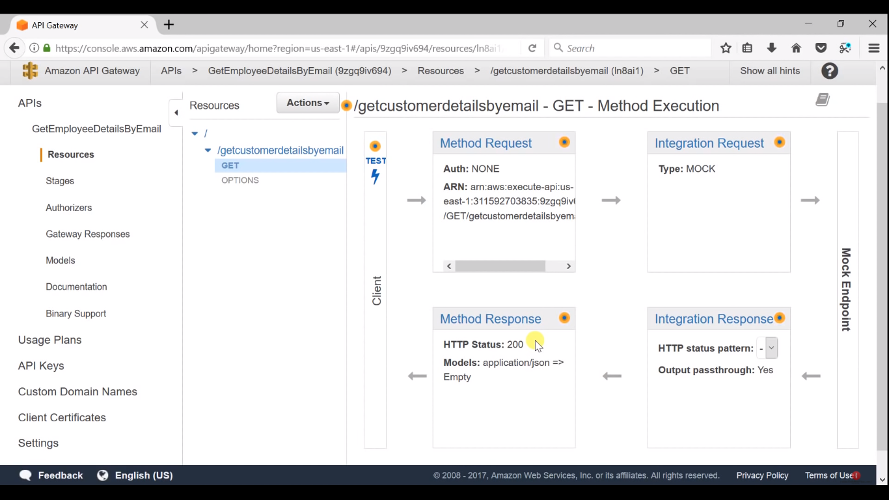

integration response

mapping templates

200

body mapping

application/json

select error

{

"FirstName":"vijayanath",

"LastName":"viswanathan"

"Email":"naresh.vurukonda@gmail.com"

}

save

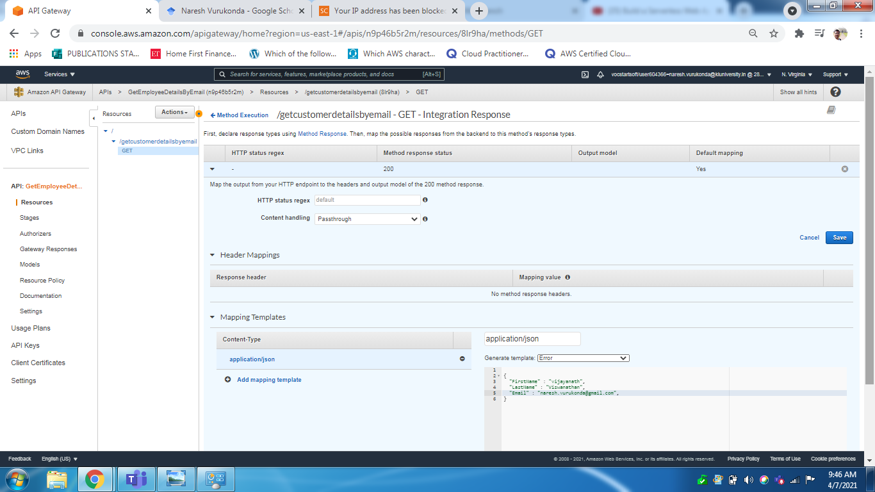

action

deploy

name: Dev

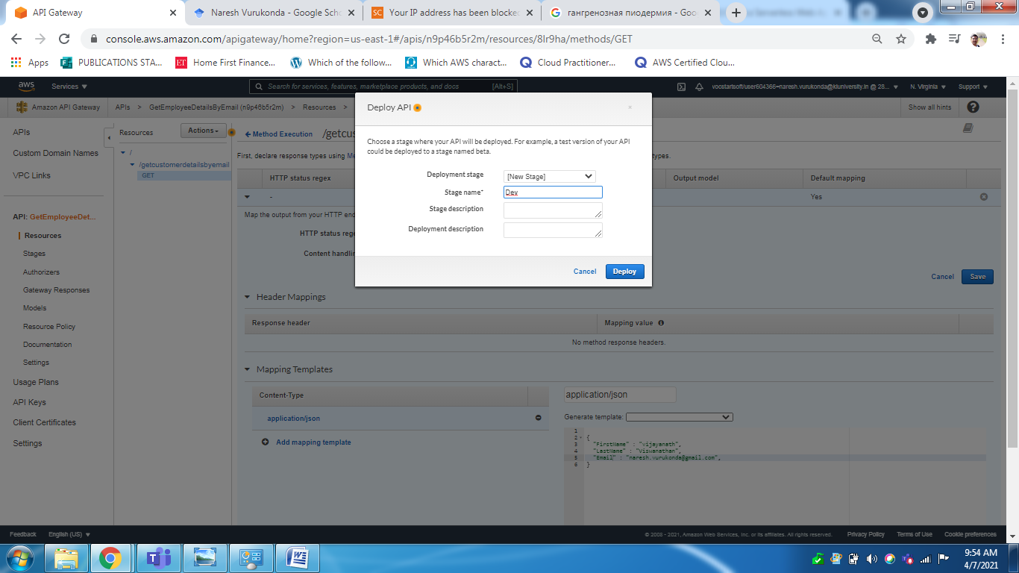

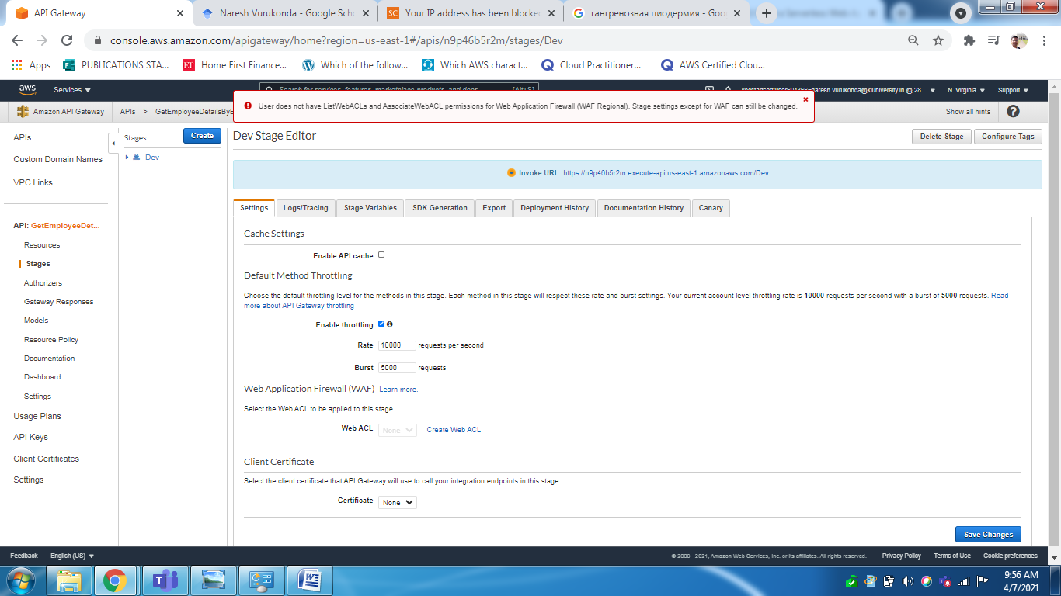

install postman web

create account

nareshvurukonda

xxxxx

select GET

type url : invoke url

<https://n9p46b5r2m.execute-api.us-east-1.amazonaws.com/Dev>

dev

Getcustomerdetailsbyemail

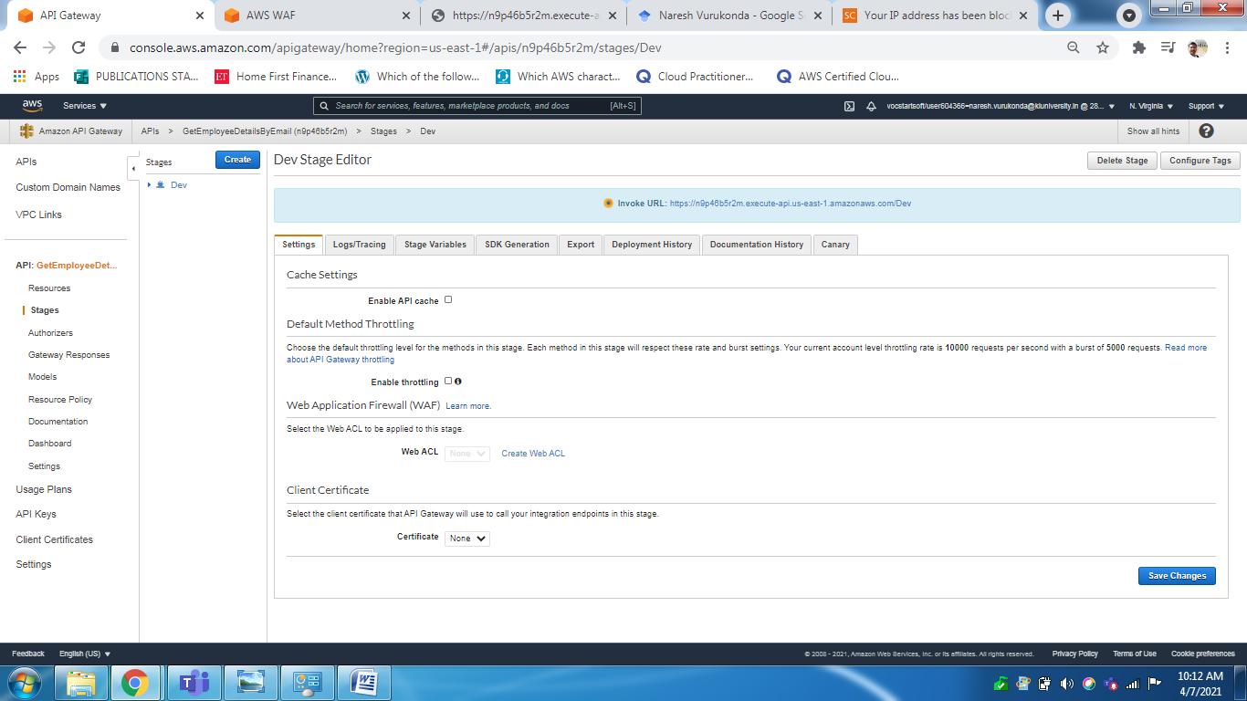

LAMBDA

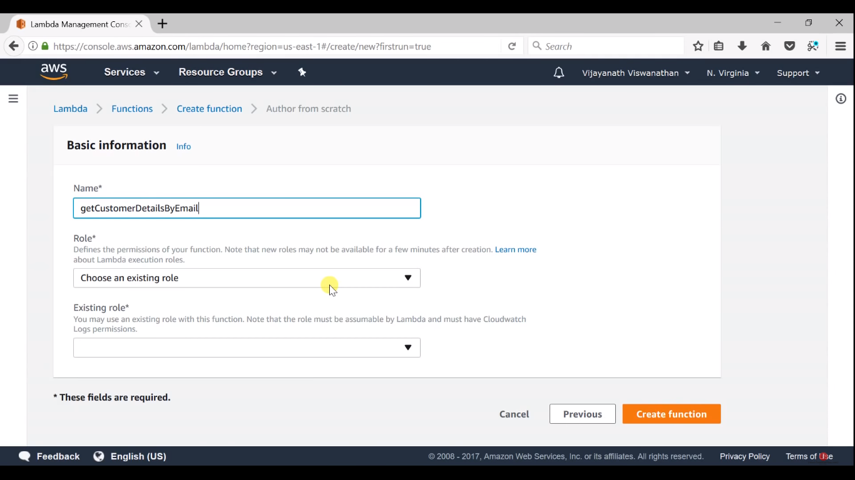

getCustomerDetailsByEmail

choose role

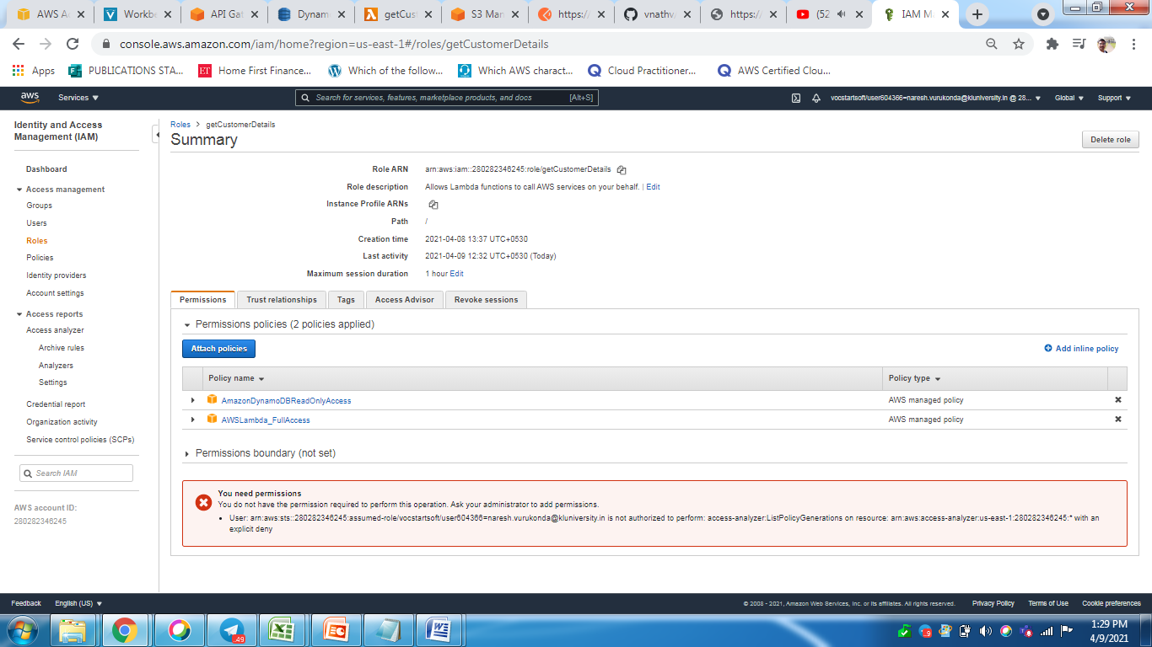

attach policy

[AmazonDynamoDBReadOnlyAccess](https://console.aws.amazon.com/iam/home?region=us-east-1#/policies/arn%3Aaws%3Aiam%3A%3Aaws%3Apolicy%2FAmazonDynamoDBReadOnlyAccess)

[AWSLambda_FullAccess](https://console.aws.amazon.com/iam/home?region=us-east-1#/policies/arn%3Aaws%3Aiam%3A%3Aaws%3Apolicy%2FAWSLambda_FullAccess)

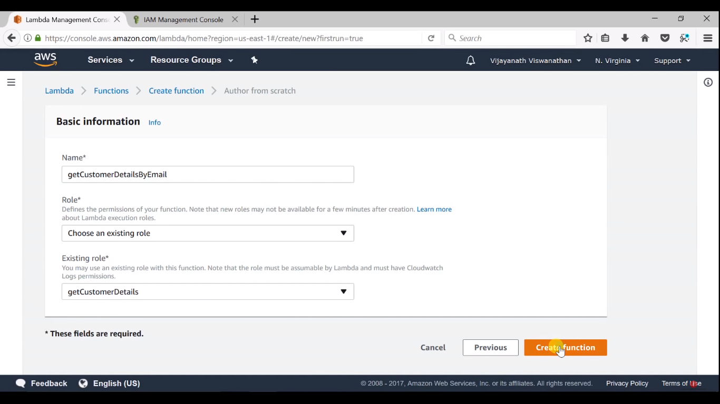

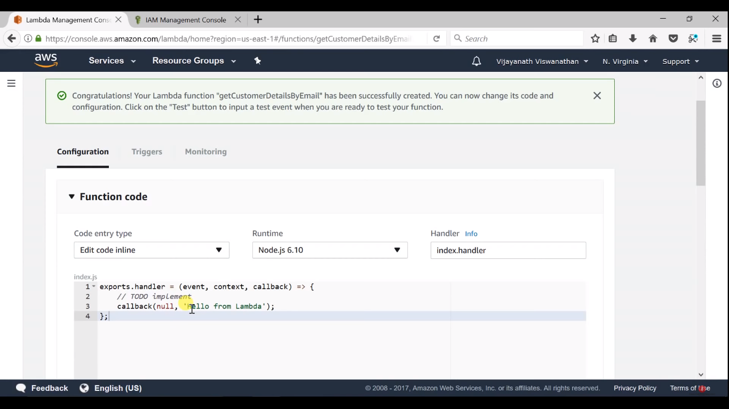

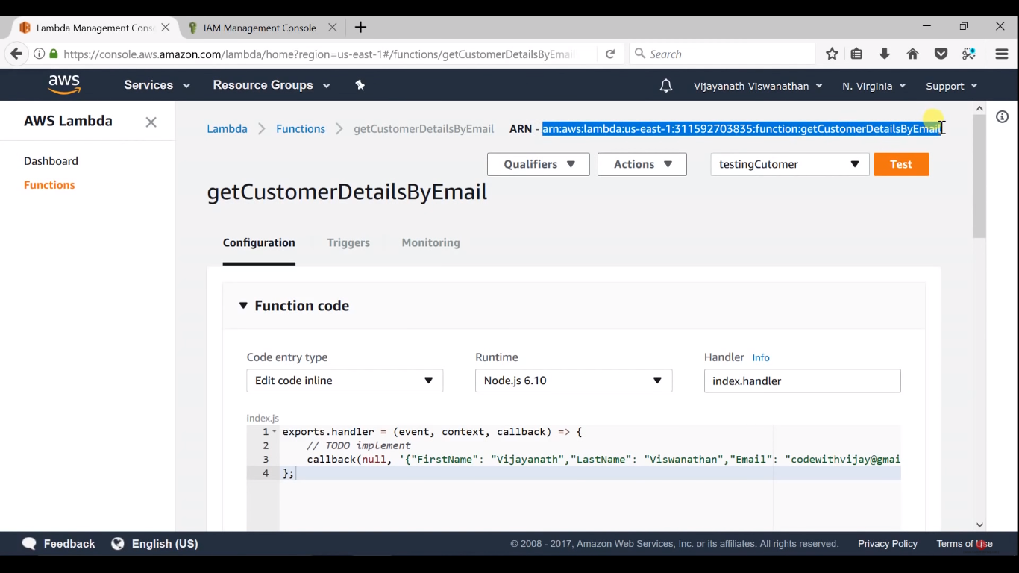

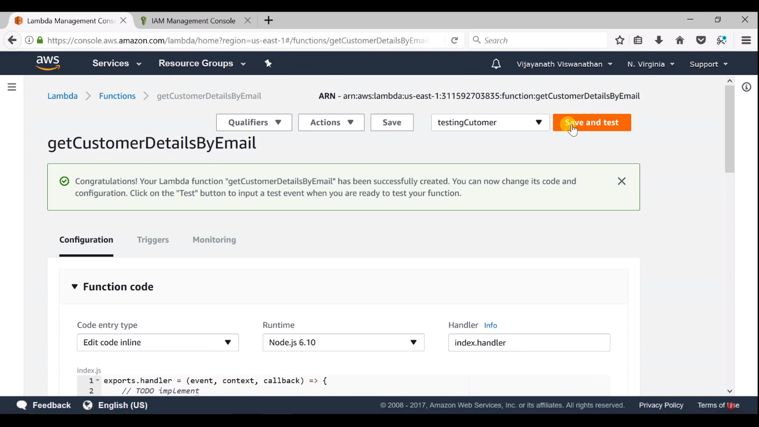

next go to

API GateWay

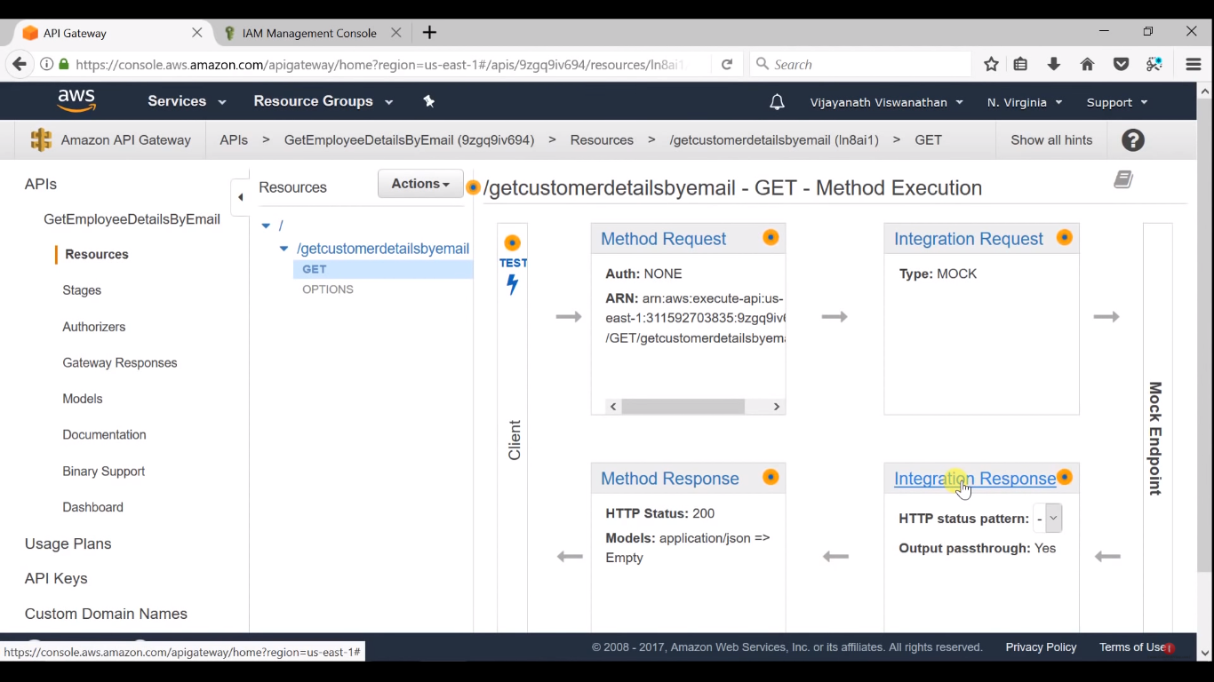

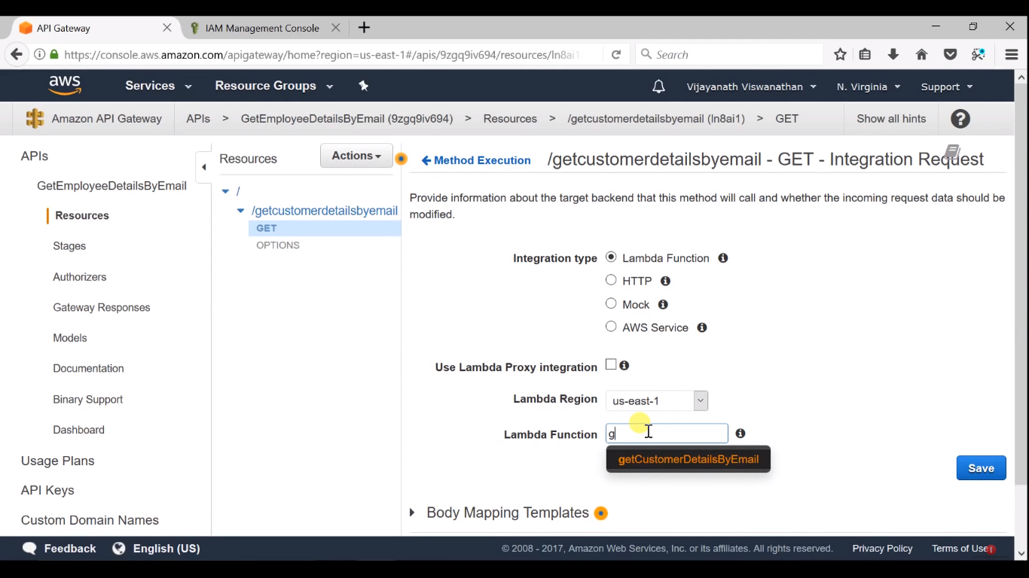

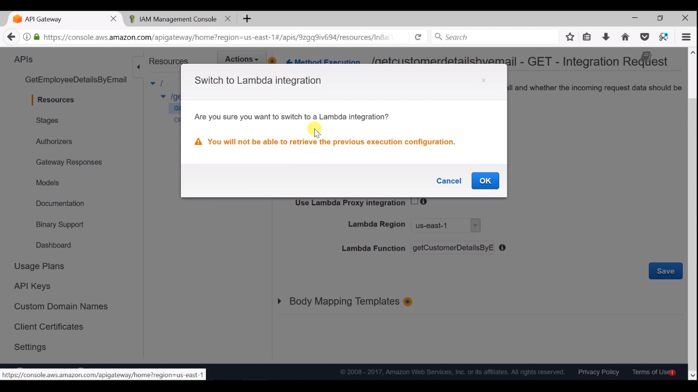

and deploy

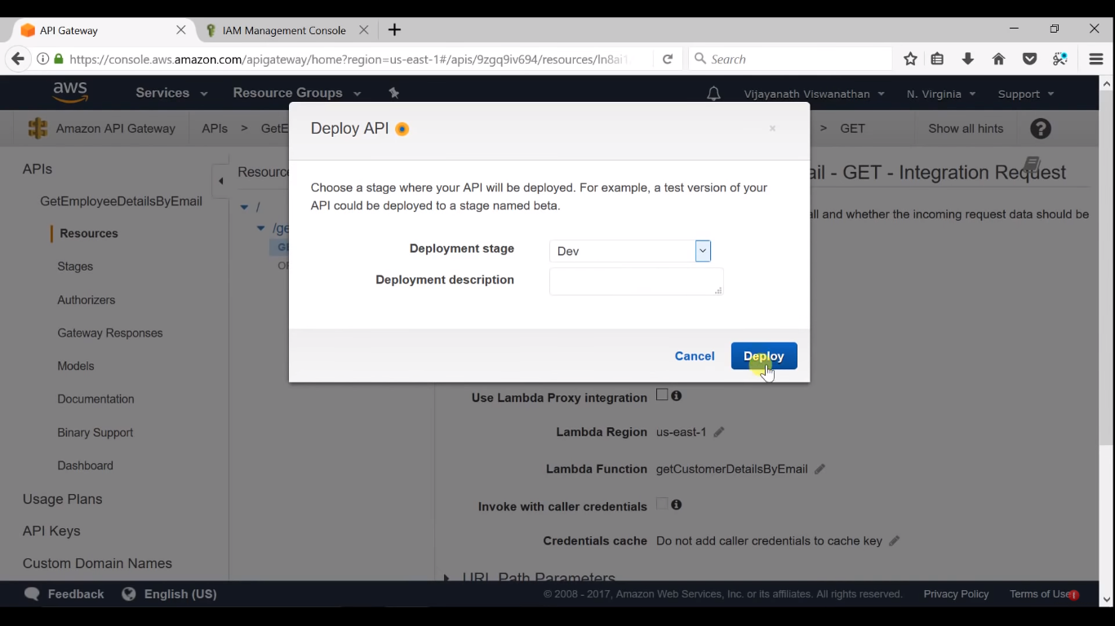

select stage Dev

invoke url

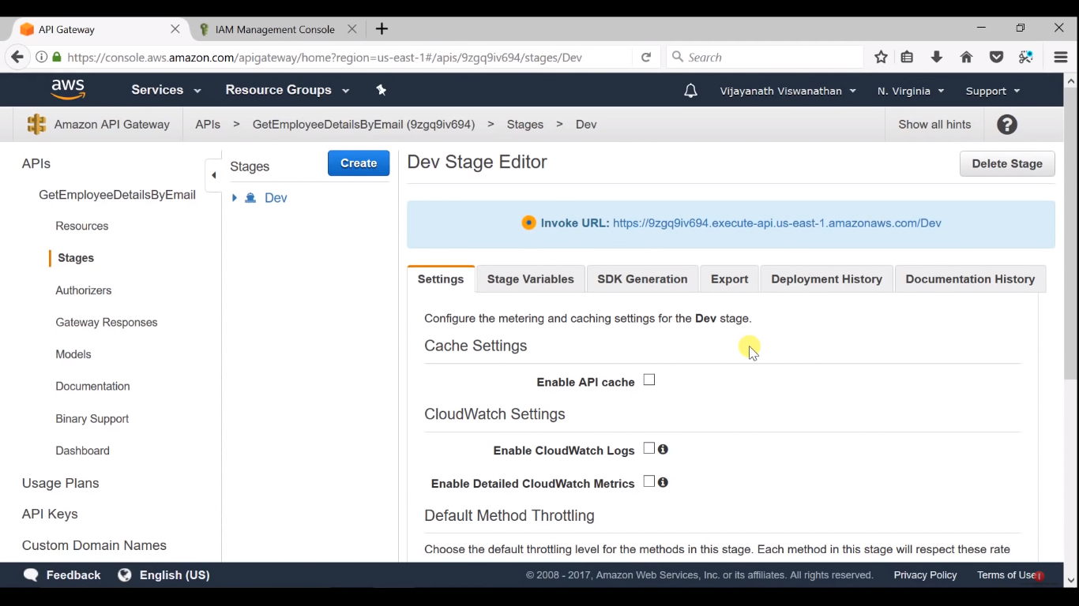

save and test

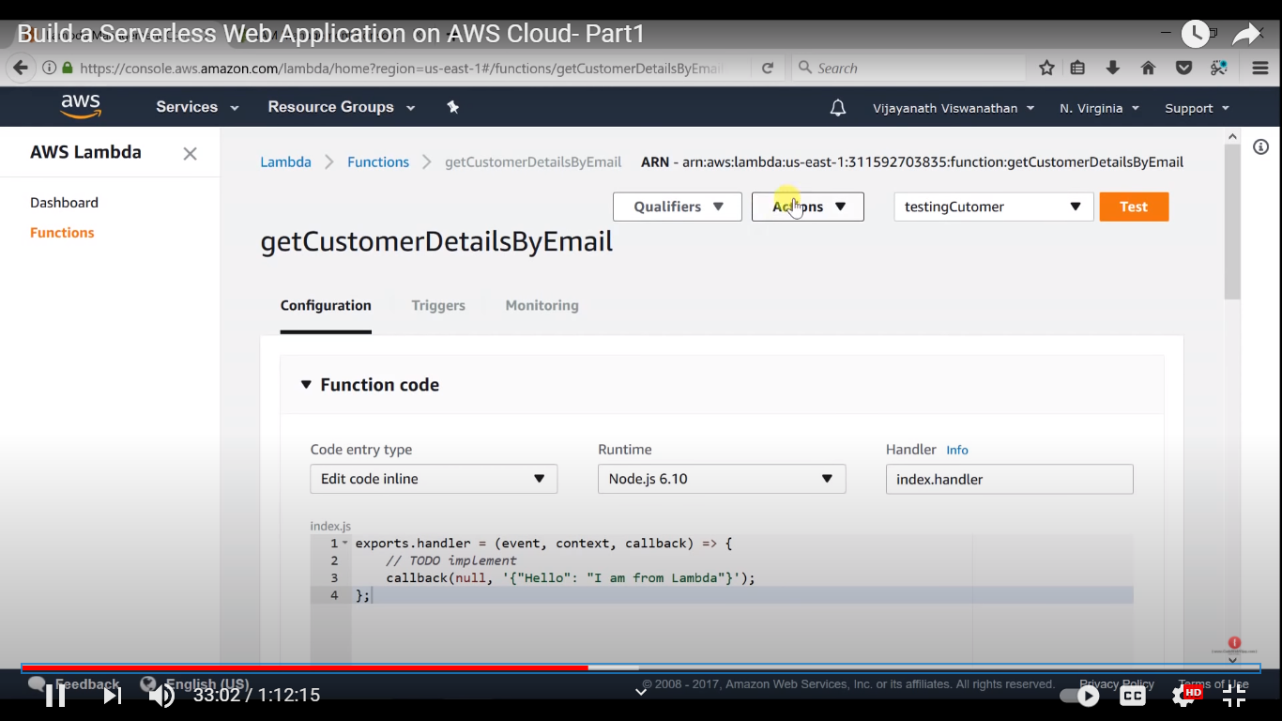

verify in postman

including

url/getcustomerdetailsbyemail

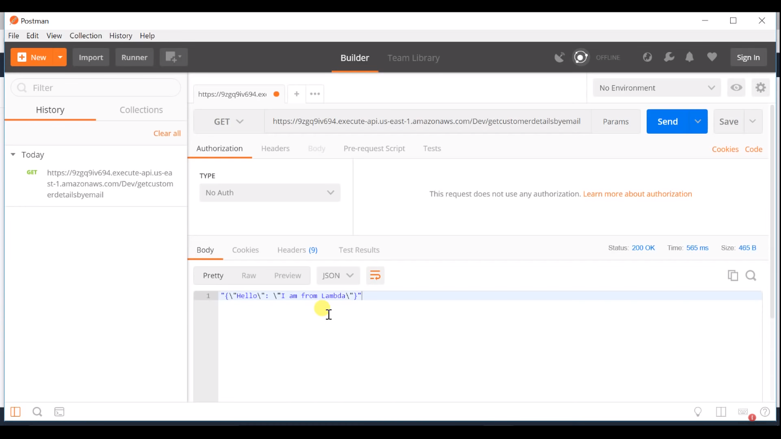

next

DynamoDB

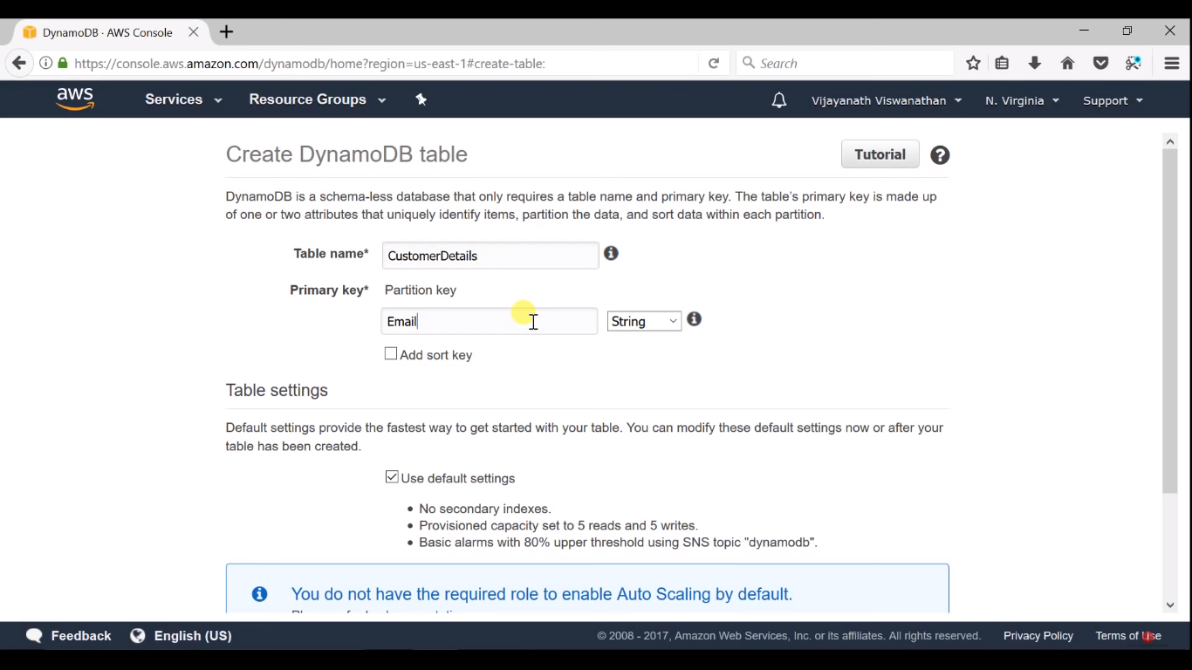

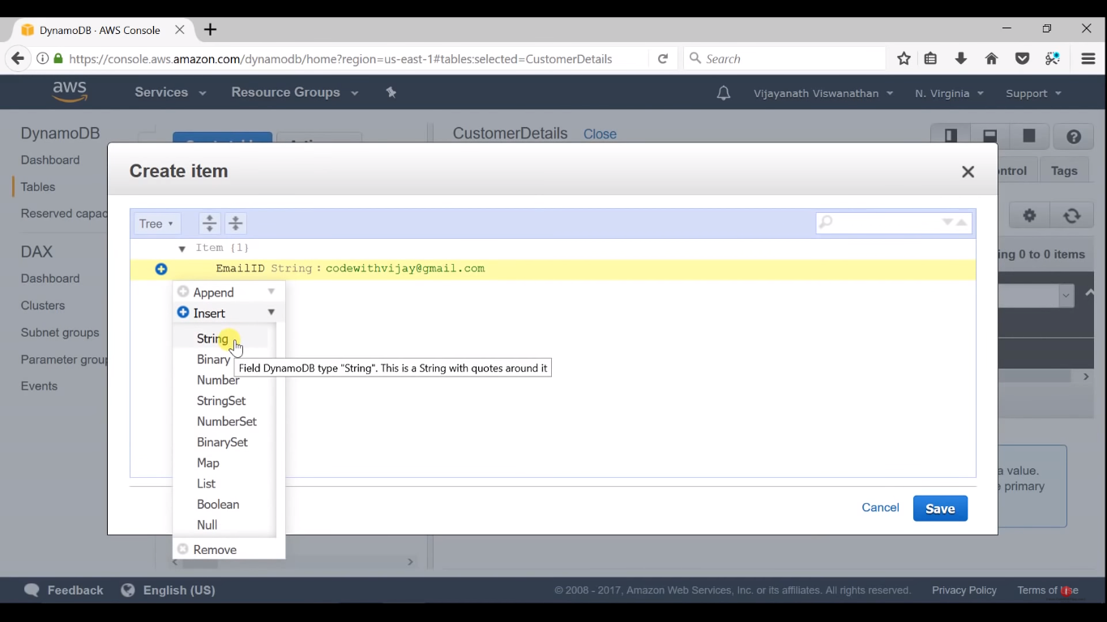

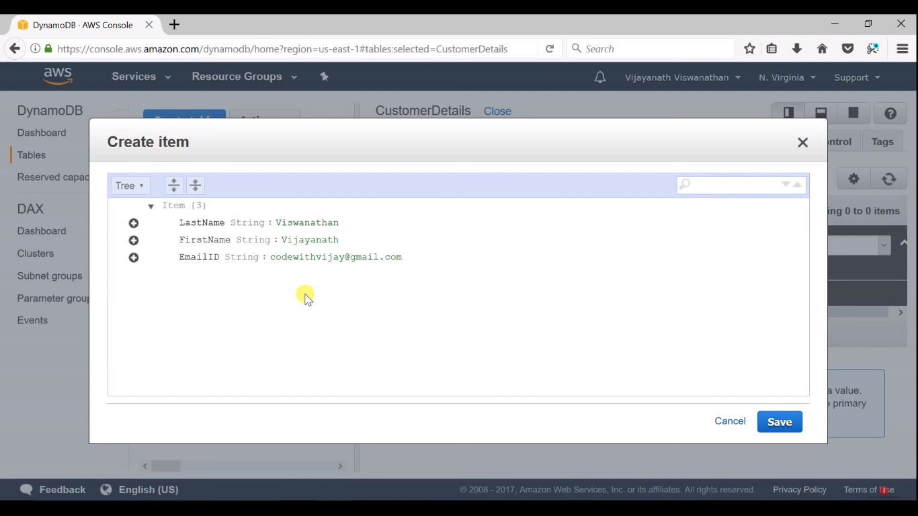

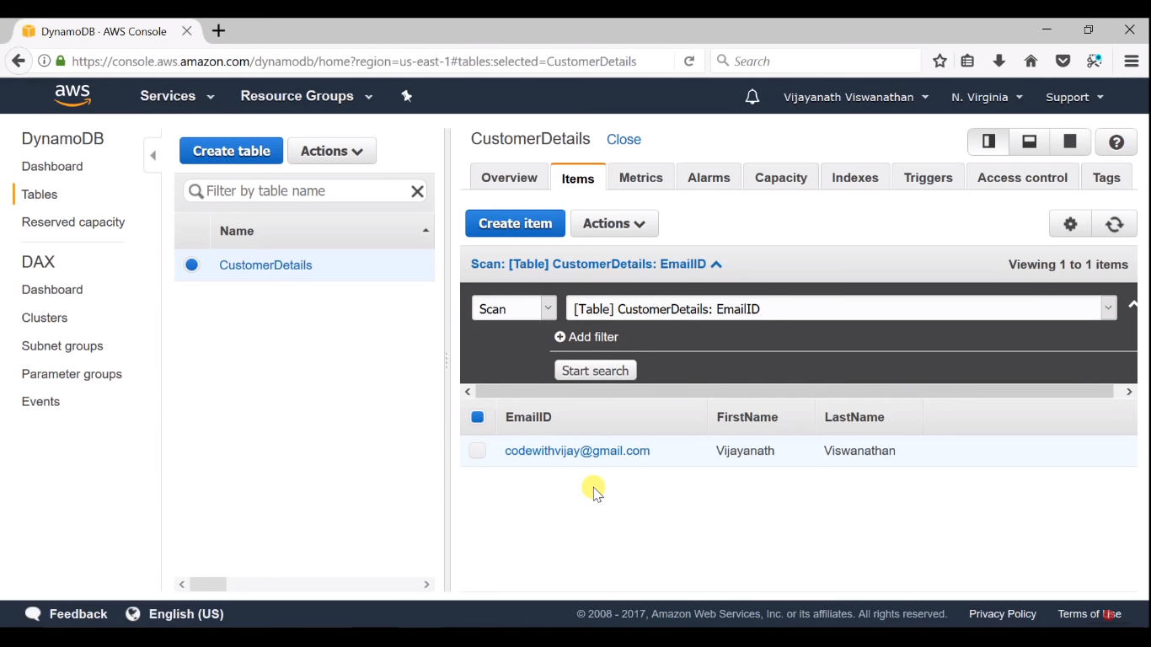like that 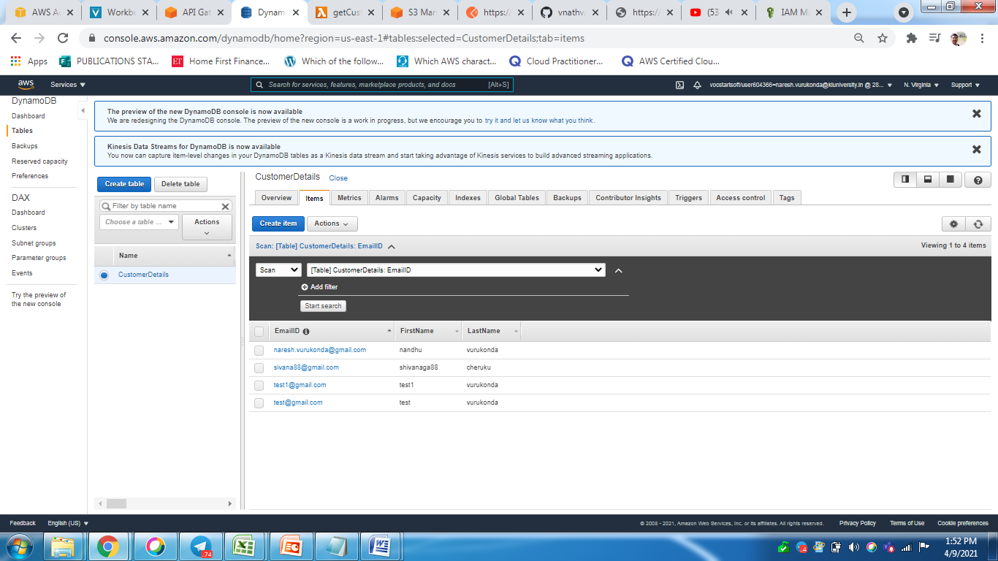

next goto

LAMBDA

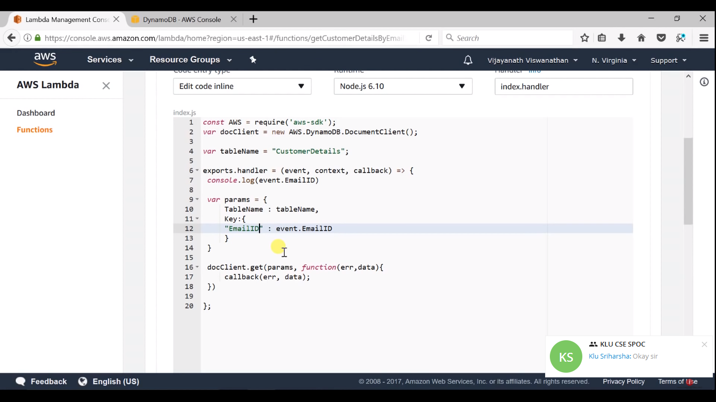

CODE:

(

const AWS = require('aws-sdk');

var docClient = new AWS.DynamoDB.DocumentClient();

var tableName = "CustomerDetails";

exports.handler = (event, context, callback) => {

console.log(event.EmailID)

var params = {

TableName : tableName,

Key:{

"EmailID" : event.EmailID

}

}

docClient.get(params, function(err,data){

callback(err, data);

})

};

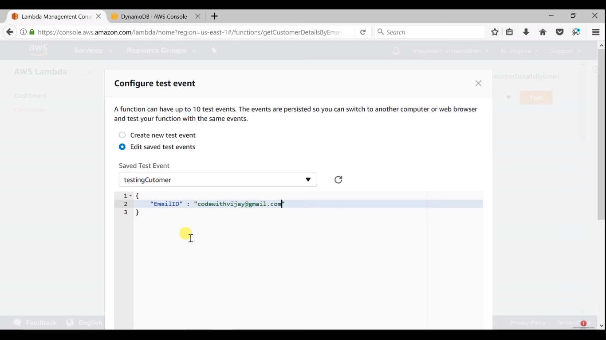

GOTO

API GATEWAY

method request

G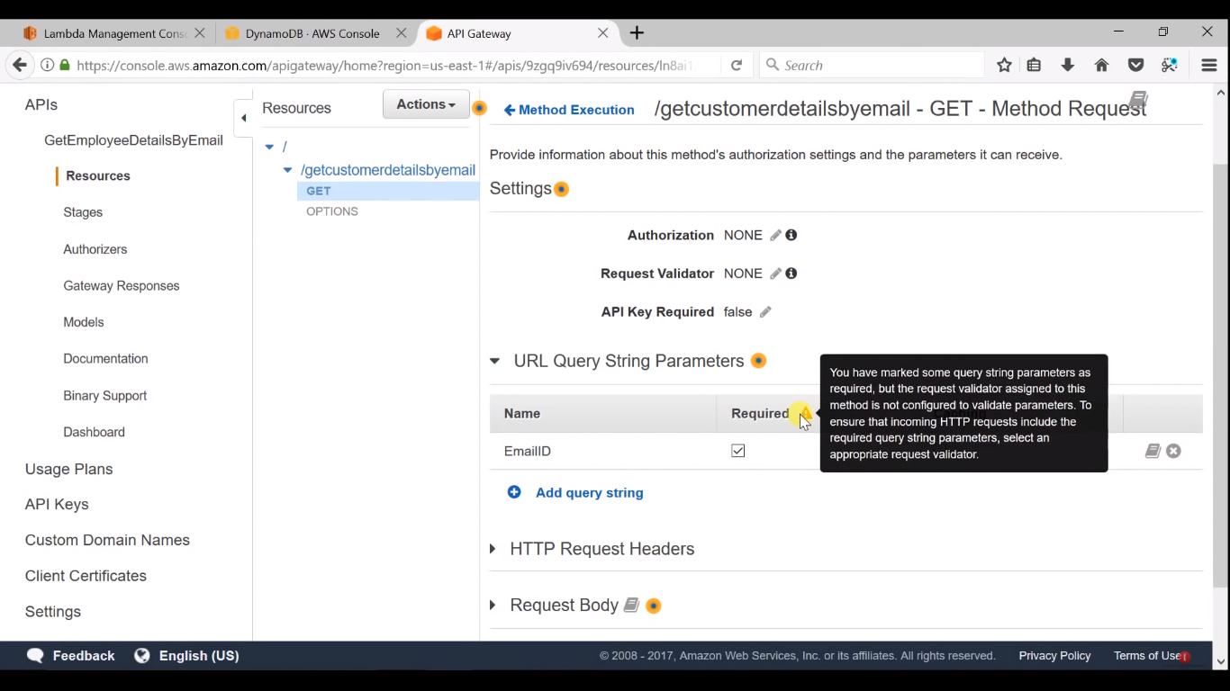

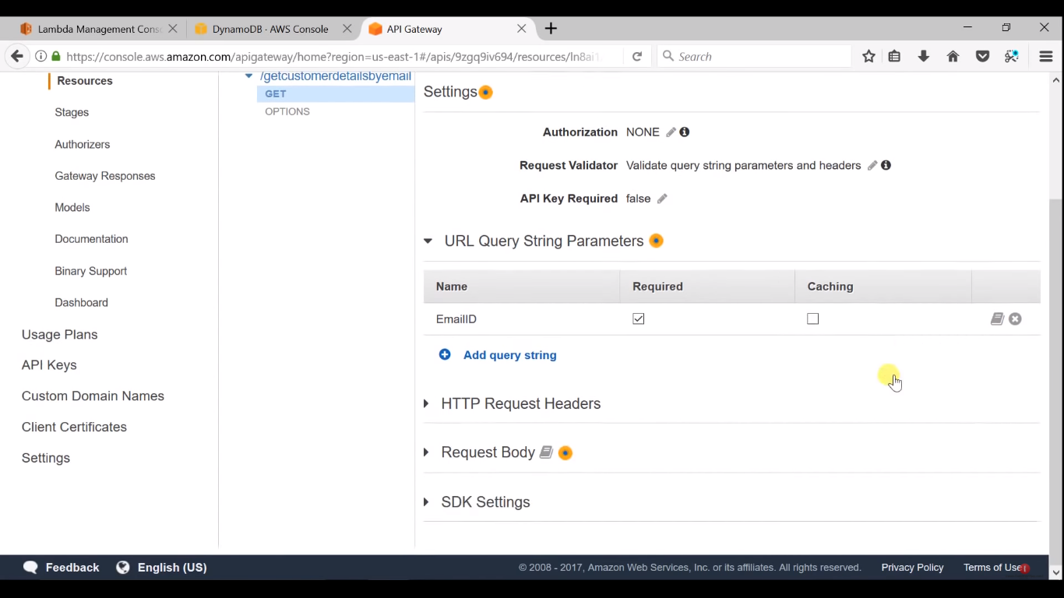

next

goto

integration request

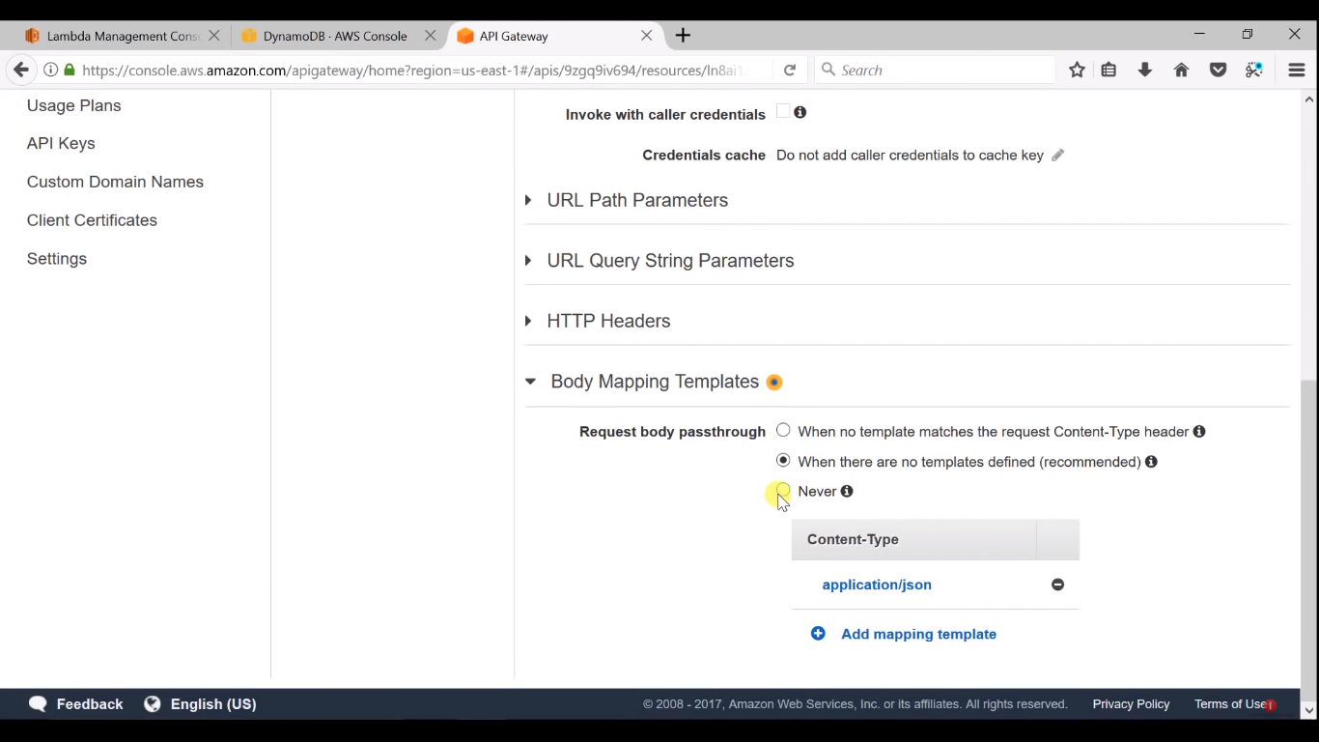

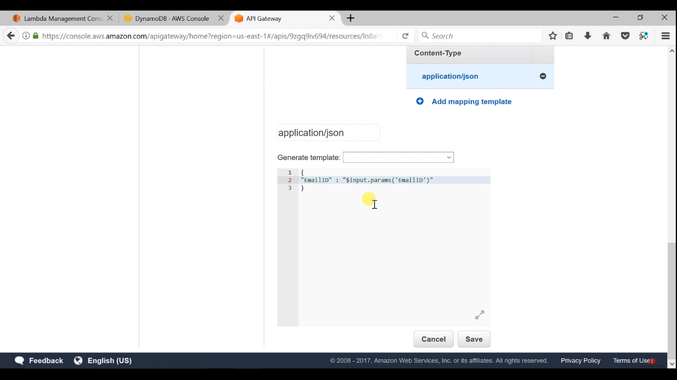

save

and deploy

stage

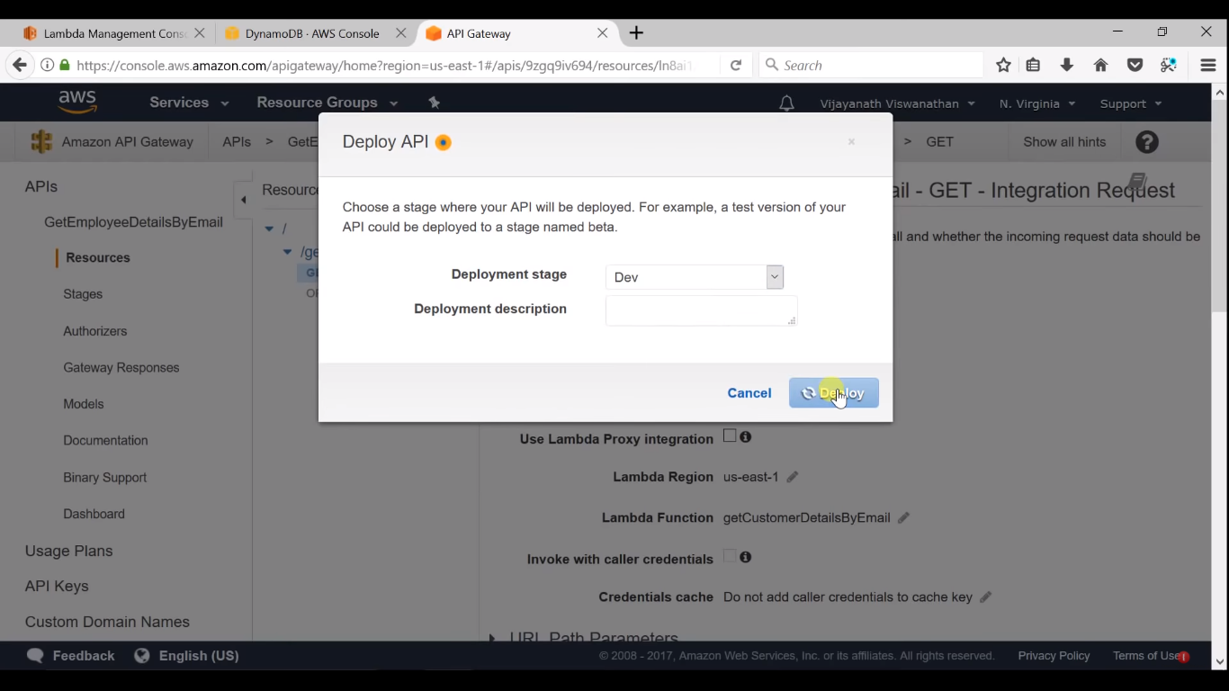

verify in postman

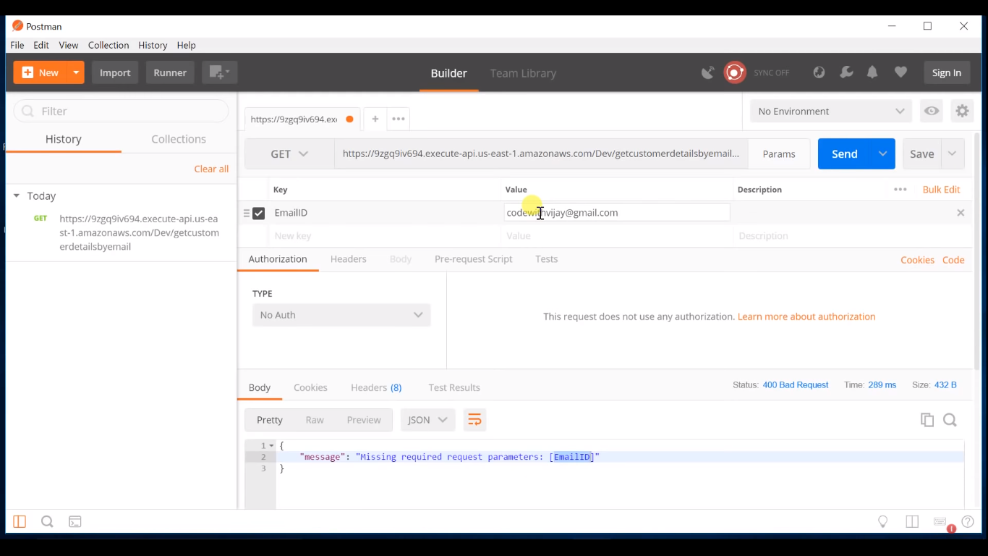

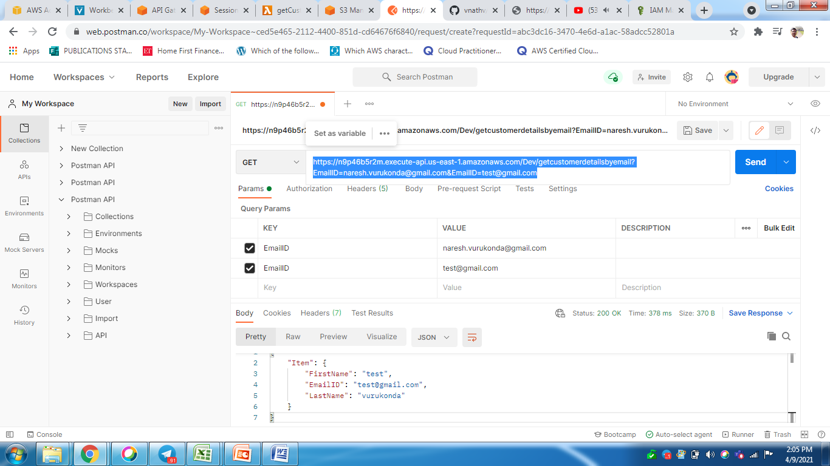

goto DynamoDB



create few more and test in postman

goto S3

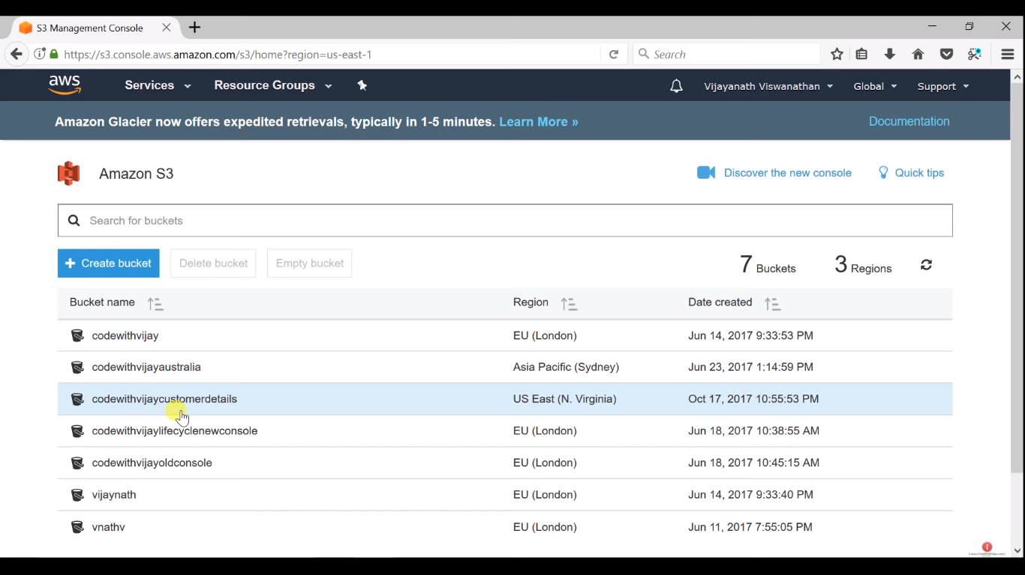

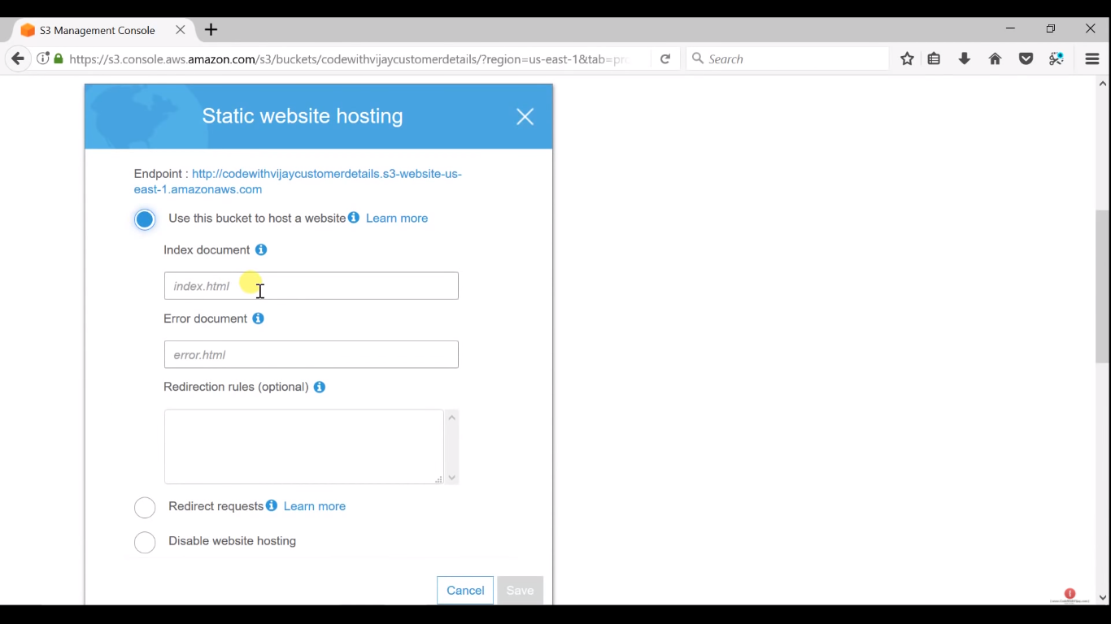

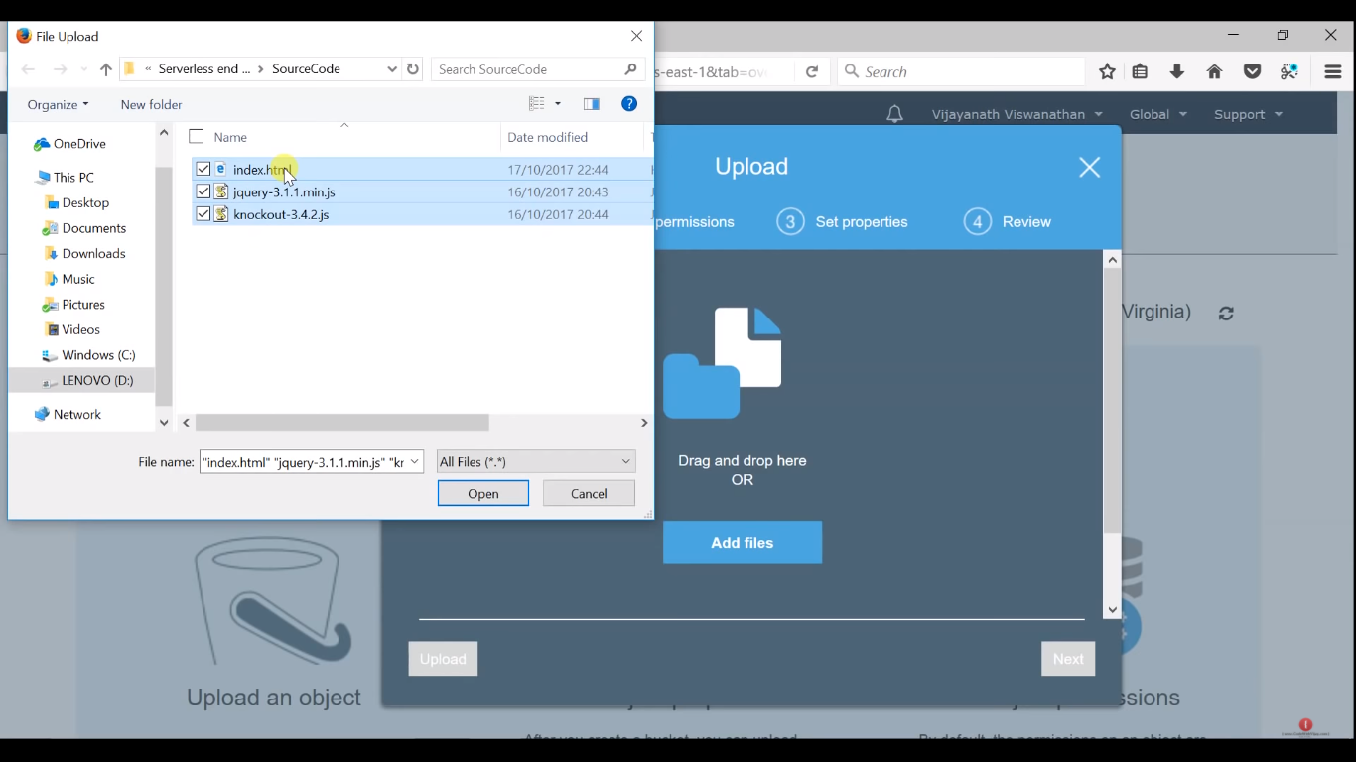

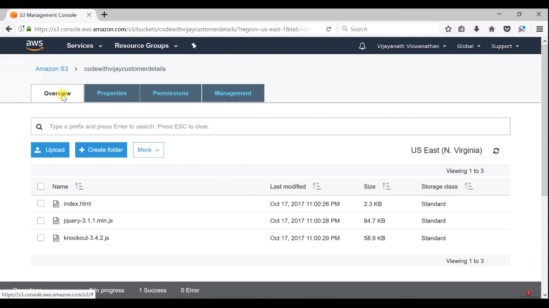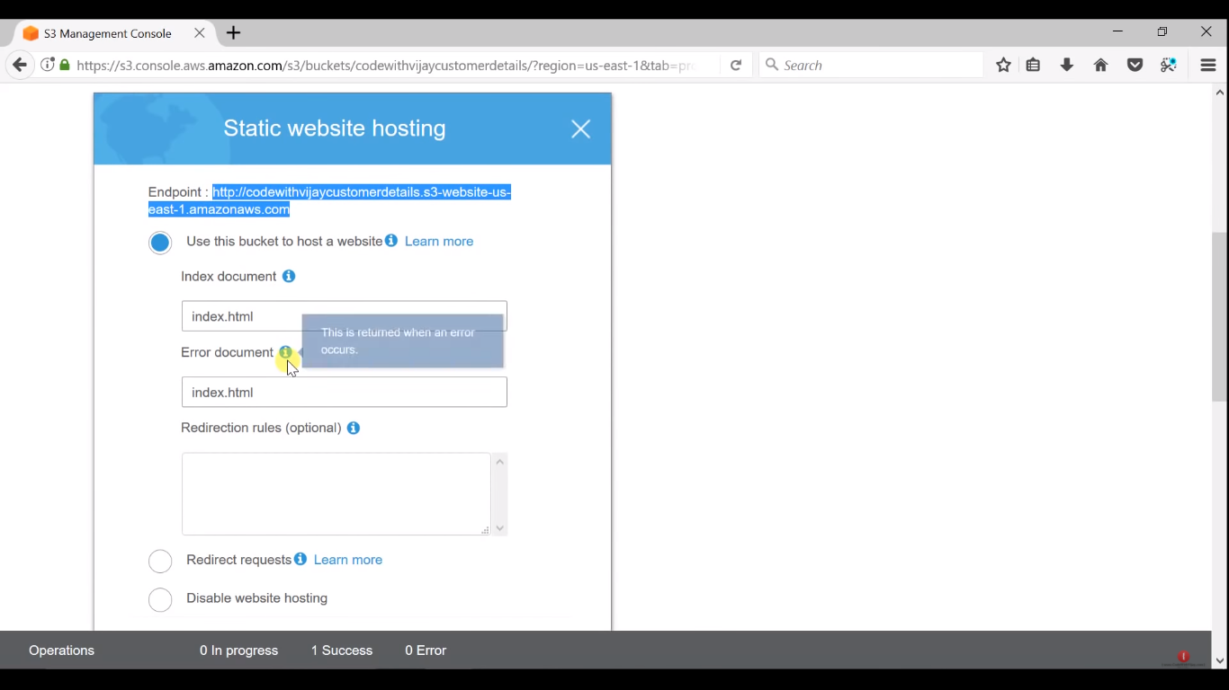

bucket policy

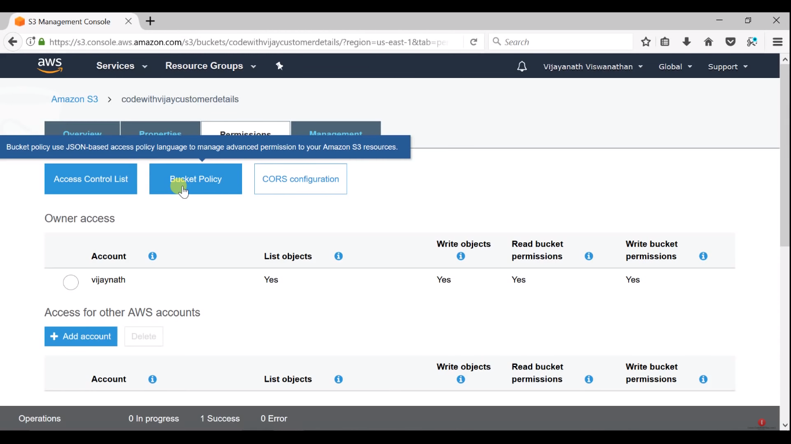

generate policy

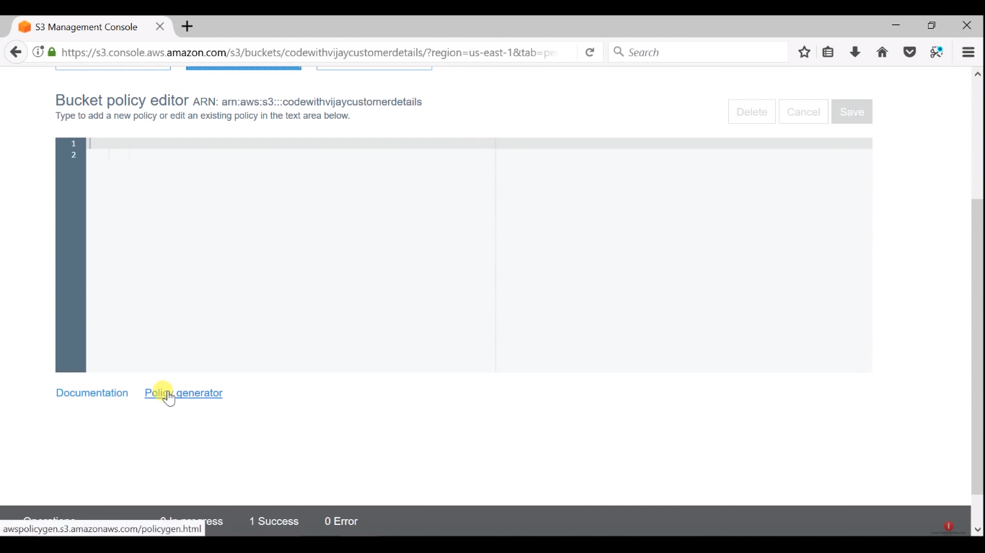

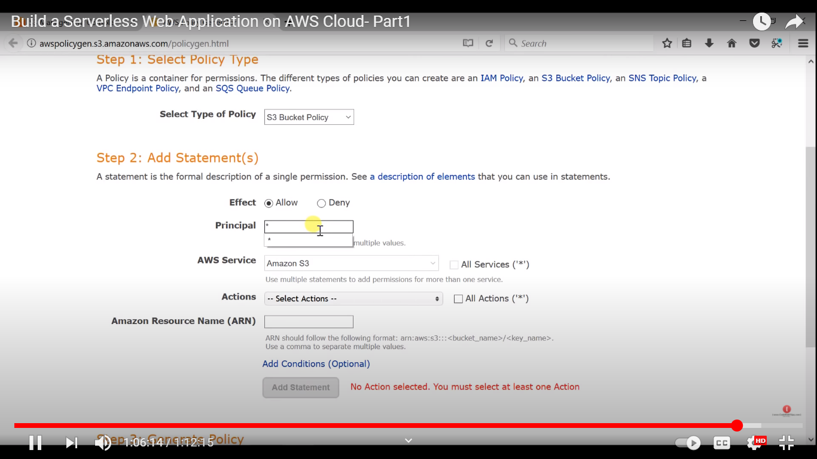

get object

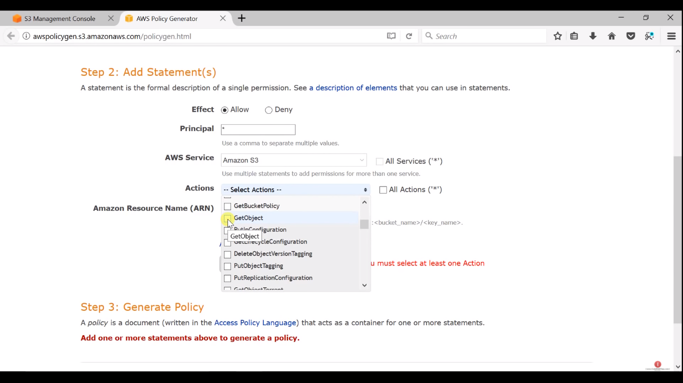ARN:

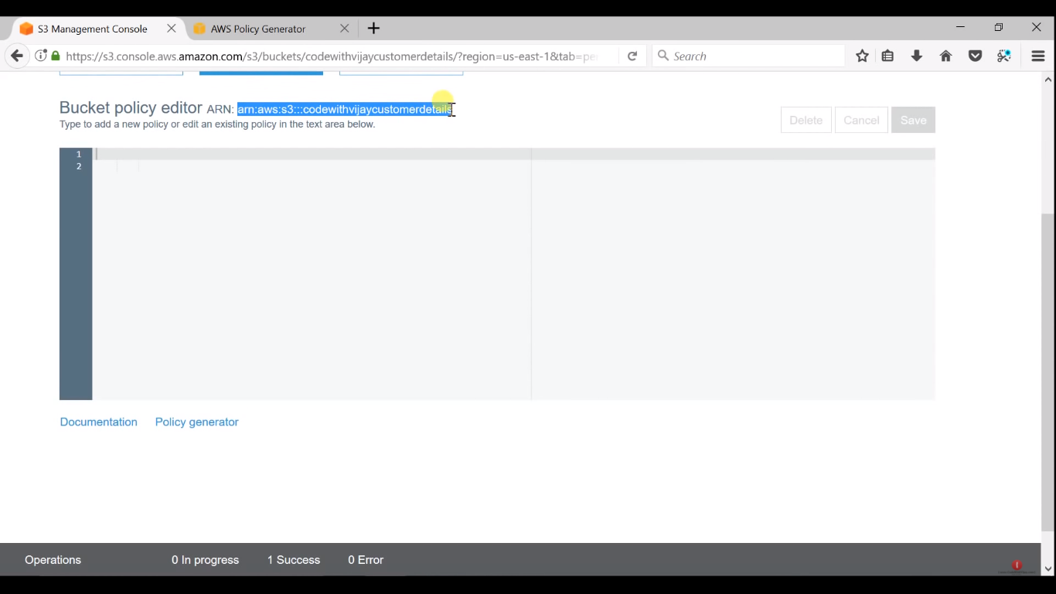

ADD STATEMENT

AND

GENERATE POLICY

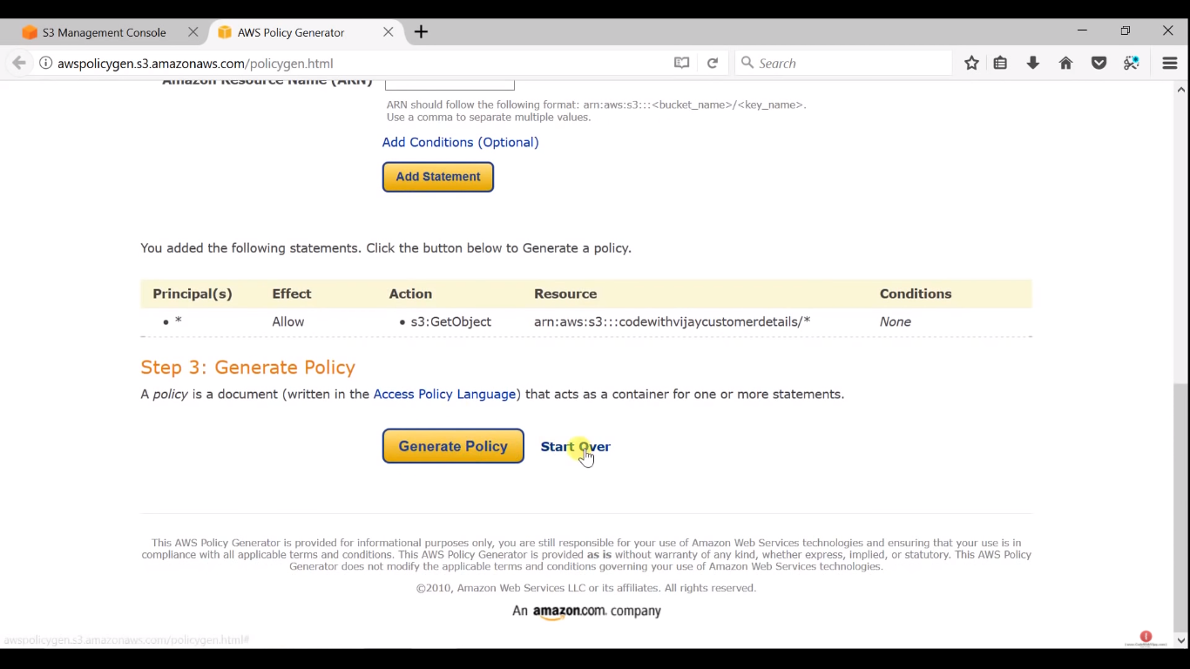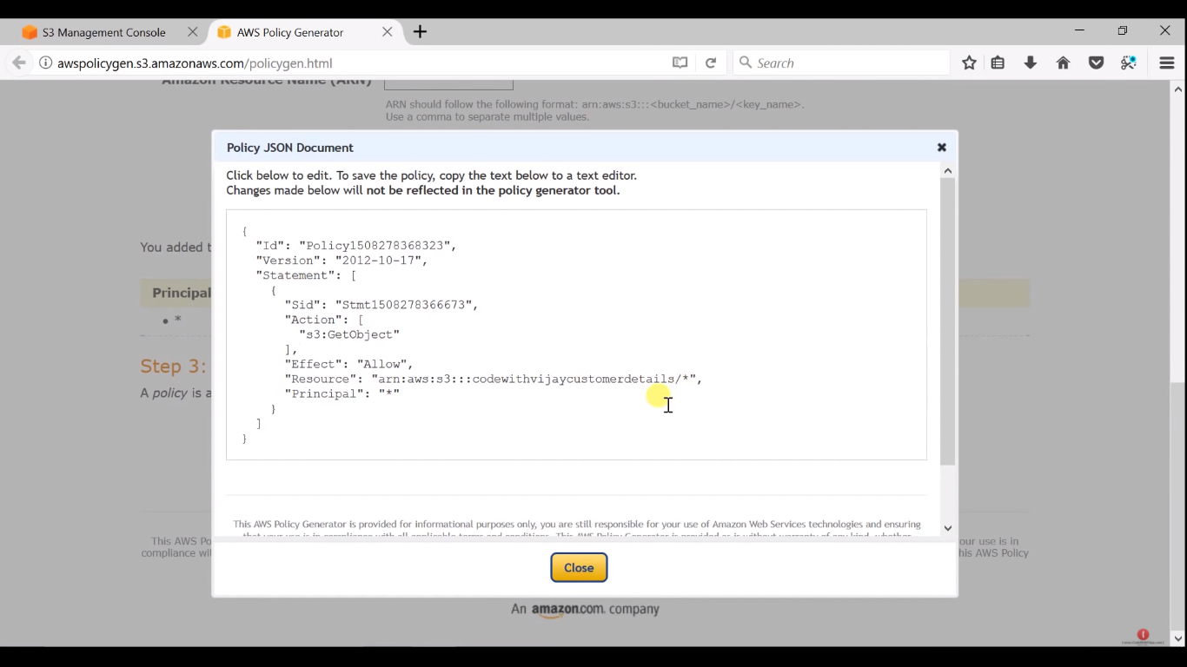

COPY

AND PASTE IT IN

EDITOR

